### LSW

Children

Younger children

*You may wish to talk to them about Pinocchio and what happened when he lied.* What happened in the end? *He became a real boy. Explain that he became a real boy when he told the truth and he was sincere. Explain that truth and sincerity goes together. If you say something without sincerity, it is as good as lying – maybe even worse if you are using the truth to mislead. If you are asked to elaborate, limit your answer to simple examples (when someone took the cookie and was asked by mommy whether he/she has eaten the cookie before he/she ate it and the person replied “no”) – you don’t want to be the one to teach this lesson to the kids.*

*Older children*

*You may want to discuss what a lie is. Would telling jokes be lying? No, there is no intention to deceive. What about flattery? And white lies? That’s a tough one. Depends on the situation I guess, which is why I limit the discussion to the older ones. What about lying to defend something good, like the church. I would think not (no need to explain clerical child abuse here).*

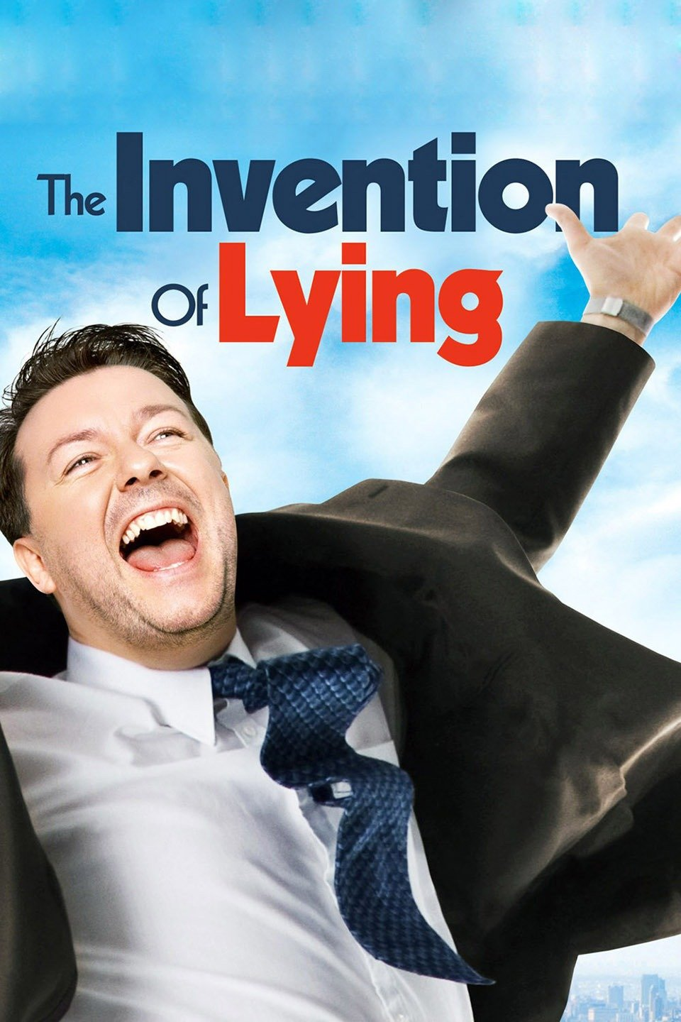Recommended watching: Invention of Lying

This is a wonderful what-if movie in which Ricky Gervaise lived in a world where everyone tells the truth all the time. This leads to hilarious situations until someone became the only person in the world who can lie. After watching it, think and reflect on what we are doing and saying everyday - how much our modern society relies on lying or the possibility of someone lying.

Year A

#### Sixth Sunday in Ordinary Time

**Concepts**

Telling the truth

**Points to note**

This reading is still part of the Sermon on the Mount. The long version of the reading for this Sunday is 5:17-37. There are a lot of messages in the long reading, which can be rather confusing and so, I have chosen the shorter reading instead. This will focus us onto two individual messages: (i) that the Christian lives by rules that are sometimes opposite to what the world thinks is good; and (ii) about swearing.

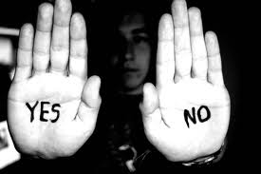

The first message will dealt with in more detail next week. So, we will focus on the second one: swearing. This is not about swearing as in using an expletive in anger, but more about promises to tell the truth. Swearing to tell the truth is so much a part of modern living that the message from the Sermon on the Mount may be confusing for children, or even adults. You see people swearing to tell the truth in court, and even the American President being sworn into office using a Bible.

Perhaps, we can keep away from the idea of swearing and more the idea behind swearing – we want people to swear because we do not trust them to tell the truth. Swearing using a religious symbol only reinforces the credibility, which the Gospel tells us is unnecessary.

**Liturgy**

Acclamation before the Gospel

Alleluia! Alleluia!

Speak, Lord, your servant is listening:

you have the message of eternal life.

Alleluia!

Gospel

*Explain that we are still with the Sermon on the Mount.*

The Lord be with you.

*All:*  And also with your spirit.

A Reading from the Holy Gospel according to St Matthew

*All:*  Glory to you O Lord

(Mt 5: 20-22, 33-34, 37)

Jesus said, “For I tell you, if your virtue goes no deeper than that of the scribes and Pharisees, you will never get into the kingdom of heaven. You have learnt how it is said to our ancestors: You must not kill; and if anyone does kill he must answer for it before the court. But if I say this to you: anyone who is angry with his brother will answer for it before the court.

“Again, you have learnt how was said to our ancestors: You must not break your oath, but must fulfil your oaths to the Lord. But I say this to you: do not swear at all. All you need to say is ‘Yes’ if you mean yes, ‘No’ if you mean no; anything more than this comes from the evil one.”

This is the Word of the Lord

**Dialogue**

What is lying? Do you lie? *If you say no, that would be a lie in itself.* Are all lies the same?  *Some untruths are part of a joke, and if it is obvious it is not true, it is OK. If the intention is to deceive, then it is not. Let’s not talk about white lies and devious lies, as some children may not be able to differentiate between seriousness of the impact of lies.*

What if there is someone who tells lies often, would you trust anything he says? What if he is telling the truth for once? Would people still believe him? What if everyone is like that? Would you like to be in a group like that? *Discuss what kind of world that would be.*

In many places, people have to use God’s name to convince people that they are truthful when they make promises. *Give examples like people swearing on the Bible in court.*  How would you feel if your mom and dad do not believe you unless they use a Bible every time you speak?

Would you prefer that people believe you just because you said so, and not because you used God’s name? *Discuss how we can build a credibility that people can believe in. Have a reputation for being truthful. How? Never ever tell lies is one; being faithful to God’s other teachings is another; always be doing whatever you say you would and not do whatever you say you would not do. It really is about building up a reputation as a person, and not just a reputation for not lying.*